**AIM :** Design a flashing of led through switch.

**APPRATUS :** 1 LED, breadboard, wires, arduino, resistor, switch.

**CIRCUIT DIAGRAM** **:**

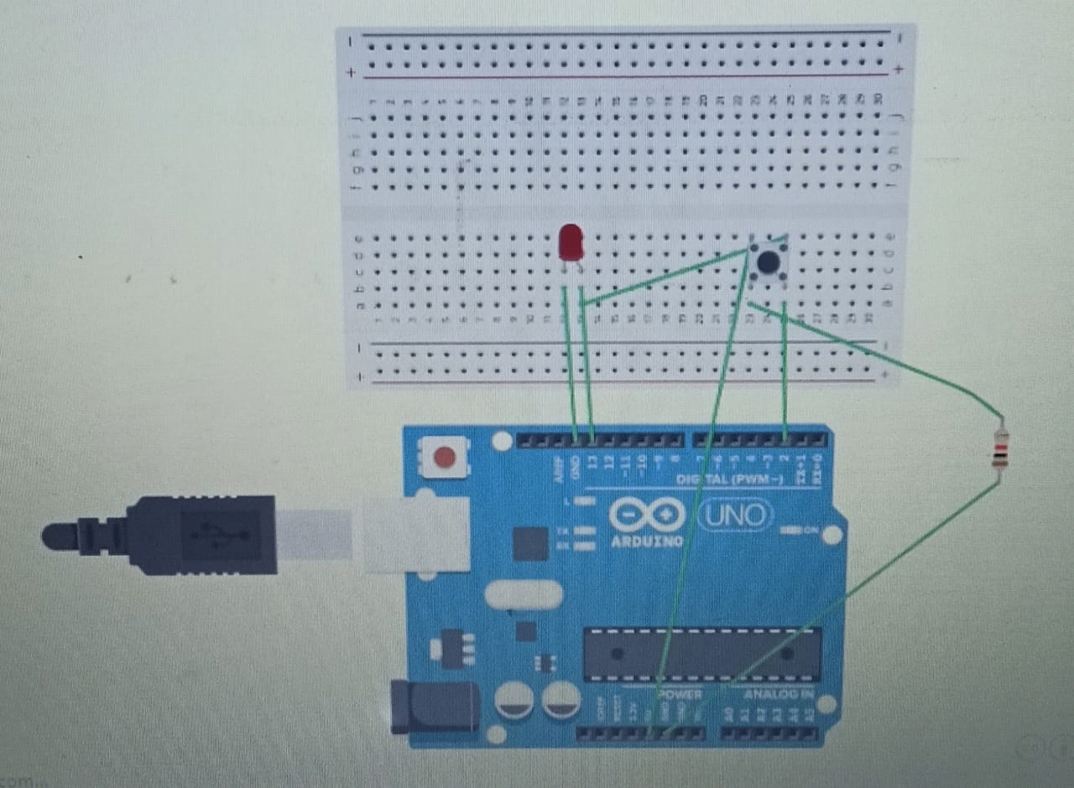

**THEORY** :

The LED has one p junction and n junction inside it, p is longer while n is shorter.

Breadboard have network of connections inside it.

**LEARNING & OBSERVATION :**

1. Learned how to connect the connection inside the breadboard.
2. Connection of LED in the breadboard and which is n side & p side of LED.
3. Learned how to upload code on arduino and work on it.
4. connection of resistor.

**PROBLEM & TROUBLESHOOTING:**

1. Connection of led in series and parallel was wrong.
2. Mistake in code uploading .

**LEARNING OUTCOMES**:

1. Connection of LED in series and parallel in breadboard
2. how to connect Arduino with switch.